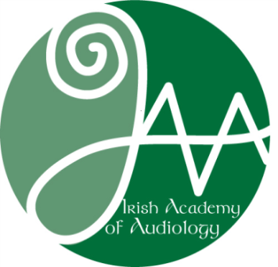

Irish Academy of Audiology
Company Limited by Guarantee (IAA CLG)

GDPR | Your Data
GDPR | What Data do we collect?
When applying for membership of the IAA we will ask you to provide the following information:
Personal Details:
Name |Contact Email Address |Contact Address | Contact Telephone No
Employment Details:
Job Title |Employer name and address | Employment status | Brief description of work
Membership Information:
| Audiology Education & Qualification Details | Registration Number of other bodies
Student Information:
Student Number | Education Details
GDPR | How we use your data
Your data is used exclusively to administer your membership and to provide the following:
- Online CPD Portfolio:
- Profession & Ethics:
  - We use your contact details to keep in touch about IAA issues and CPD/Conference details

GDPR | Your right to be forgotten
We keep your data for 3 years following lapse of membership. However, at any stage you can request that we delete this data.

